**USER GUIDE**

**Class Book System**



Table of Contents

**Introduction3**

**Log-In4**

**Admin5**

Create Teacher5

View(Modify) Teacher7

Delete Teacher8

**Teacher9**

Create class9

Add student9

View/Modify student10

Delete student11

**Student12**

**Parent12**

**Introduction**

When opening up the system, the first window that will pop-up will be the “Class Book ” window, which serves as the Log-In page.

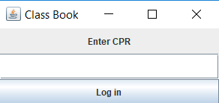

In the system, there are 4 “types” of entities : an admin, teacher, student and parent, so, depending on the data you input in the “Enter CPR” text field, you will be granted access to the features of one of these 4 entities (granting that the data you input in the text field is correct).

**Log-In**

To log into the system, you have to enter your assigned CPR code/pass code in the “Enter CPR” text field. After that, the next step is to press the “Log-In” button.

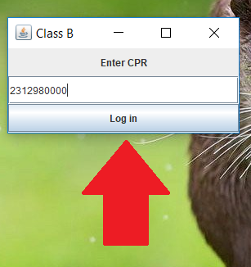

If that data that you entered is correct, then, by pressing the “Log In” button you should be sent to your “features” page.

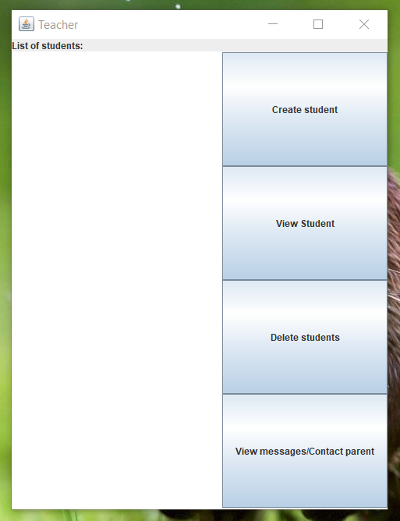

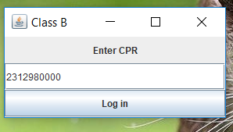

If that data that you entered is invalid, then, by pressing the “Log In” button you will get a “Login error”. In this case, press the “OK” button, which will close the error window, and try and input your data again, making sure that what you enter is correct.

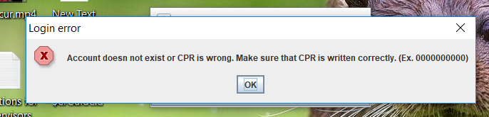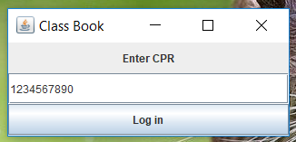

**Admin**

To acces the admin features, in the Log-In text field, you have to input the passcode “BigBrother” and then click the “Log In” button.

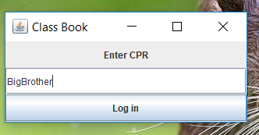

## Create Teacher

To create a teacher, you first have to click the “Create Teacher” button from the “Administrator access” interface.

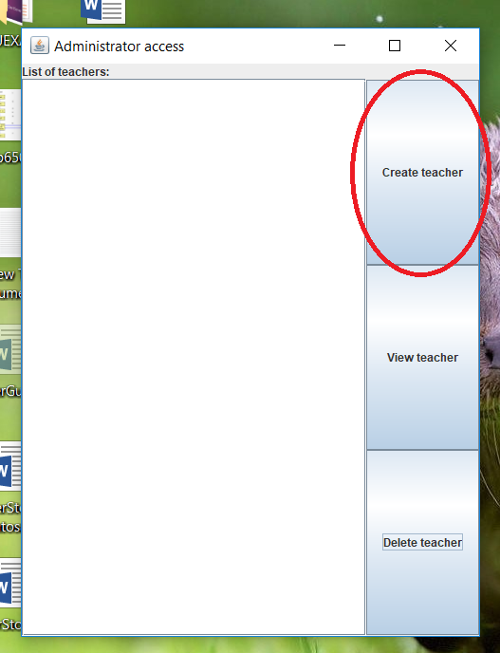

After pressing the “Create Teacher” button, the “Create Teacher box will pop up. Here, you will have to input the name and the CPR code of the teacher (which will also be used as a log-in input for the said teacher). Once you enter the specific data for the teacher, you will have to click the “Save” button, which will save the Teacher in the Teachers List. You can also cancel the whole process by clicking the “Close” button, which will close the “Create teacher” box, without saving any data.

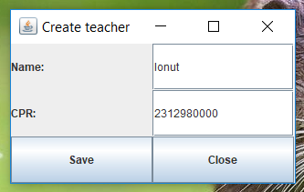

Make sure that the CPR code you input in the CPR box is 10 digits long, otherwise you will be prompted with an error, which you can close by clicking the “OK” button and try input a valid CPR code.

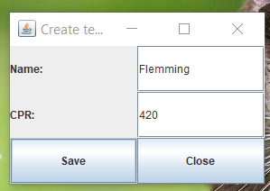

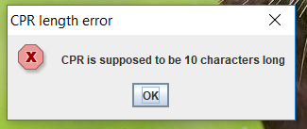

# View/Modify Teacher

To modify a teacher, you will first have to click an already created teacher from the “List of Teachers”, found in the Administrator access interface. After you have a teacher selected, click the “View Teacher” button.

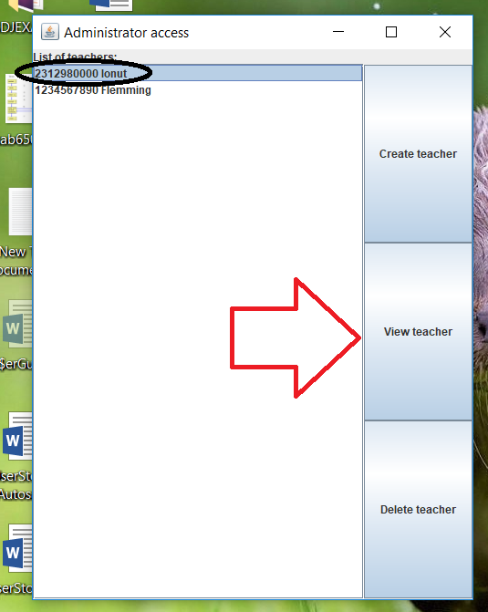

The “Edit Teacher” window will open for the selected teacher, where you will be able to input a new name for the teacher. To save the new name click the “Save” button, or to cancel the process press the “Cancel” button, which will close the window and not save any data.

(Keep in mind that the CPR of the teacher can not be changed once he is created, and the only solution is to delete the teacher and create a new teacher with the same name but with the different CPR – this will also delete all the data associated to the teacher : e.g a class, students, parents)

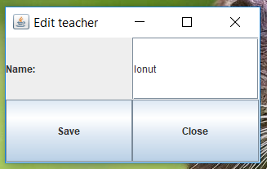

# Delete Teacher

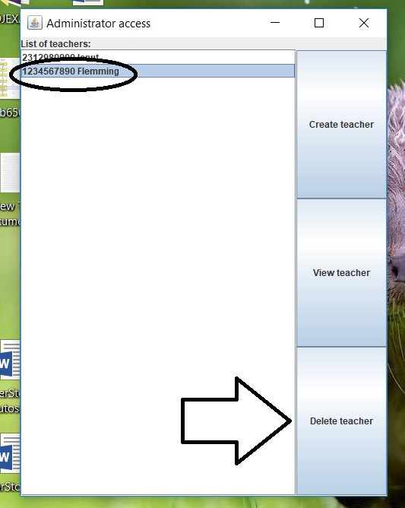To delete a teacher, you will have to first click one of the teachers from the “List of teachers” and then click the “Delete Teacher” button from the Administrator Access interface. A thing to keep in mind is that by deleting the teacher, all the data associated to this teacher such as a class, students and parents will be also deleted.

–

**Teacher**

To access the teacher features, you just have to log-in normally with your assigned CPR code.



# Create class

The first time you log-in as a teacher in the system, you will be asked to create a class. You have to input the name of the class in the “name” text box and then click the “Create Class” button, which then will send you to your features page.

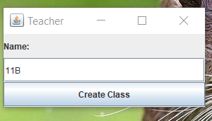

# Create student

To create a student, you will first have to click the “Create student” button from the “Teacher” interface.

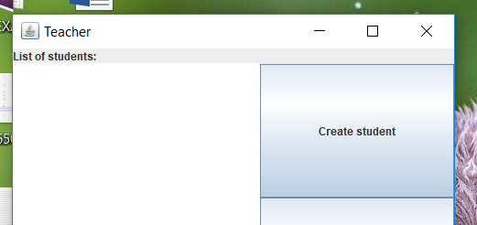

After clicking the “Create Student” button, the “Add student” interface will pop-up. Here, you will have to enter the names of the student and of the assigned parent and also the CPR codes assigned to each of them (keep in mind that they will also be used as a login input for the student and the teacher) - the CPR codes have to be exactly 10 digits long, otherwise an error message will pop up. You can also input the attendance and grades for the assigned courses, but they can be also left blank for later input.

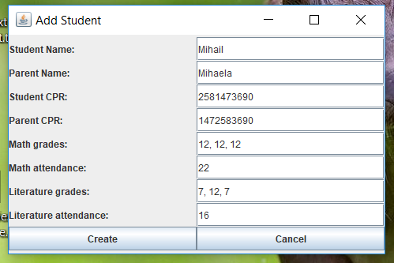

# View/Modify Student

To modify a student, you will first have to click an already created student from the “List of students”, found in the Teacher interface. After you have a student selected, click the “View Student” button.

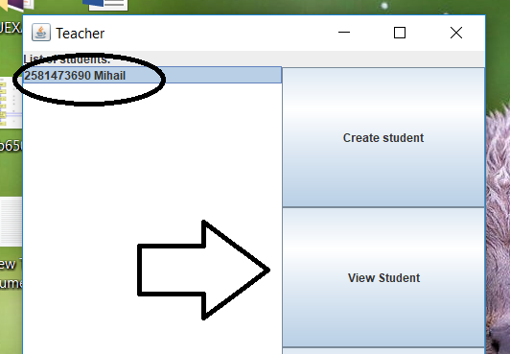

To modify a student, you will first have to click an already created student from the “List of students”, found in the Teacher interface. After you have a student selected, click the “View Student” button. The “Edit Student” window will pop-up where you can change the name of the student or of the assigned parent, and also fill-up/edit grades and attendance. After you input the data, you can click the “Save” button to save it, or, if you want to cancel the editing you can press the “Cancel” button which will close the edit window without saving anything.

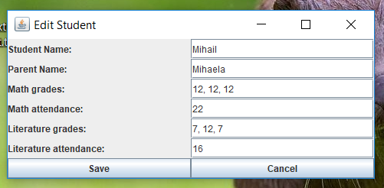

# Delete student

To delete a student, select a student from the “List of students” and click the “Delete student” button (this will delete all assigned data of the student, such as grades, attendance and parent).

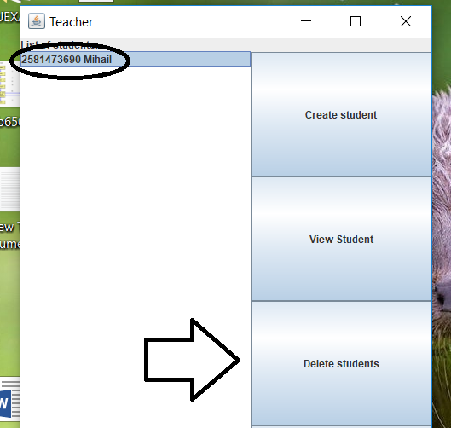

**Student**

To access the student features, you will have to log-in with a student CPR. This will open up the “Student access” page, where you will be able to see the grades and attendance of all the subjects.

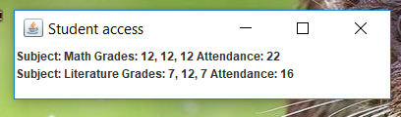

**Parent**

To access the parent features, you will have to log-in with a parent CPR. This will open up the “Parent access” page, where you will be able to see the grades and attendance of all the subjects of the assigned student.

